Monte Carlo Simulation

Lecture notes
- Mathematical modelling
  - Key performance metrics needed
  - Variables driving these performance metrics needed
    - Parameters: known and fixed
    - Control variables: changeable
    - Uncertain numbers: unknown and not controllable by you
  - Relationships between variables and performance metrics
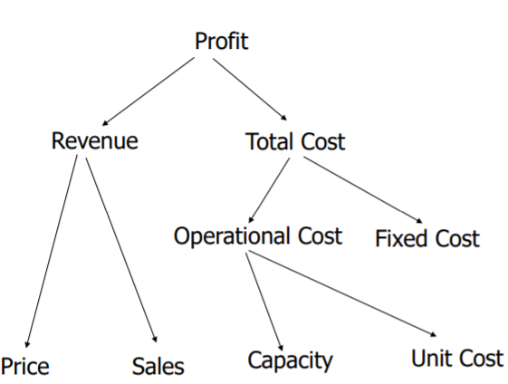
- Value driver tree. Always have 3 approaches: static model, what if analysis, Monte Carlo simulation
  - Shows profit as a function of revenues and cost, for example

- Static model – plug the values for cost and revenue in to obtain a profit figure, which we then discount to find the project’s NPV. Numbers-in-numbers-out approach
- Sensitivity analysis – range of numbers in-out approach. Calculates the range of output values corresponding to a range of input values of one uncertain variable
  - Done in a data table – show how profit varies as demand varies, keeping other inputs fixed.
  - Tornado diagram compares relative importance of uncertain inputs. However sensitivity result is flawed as it is based on the average values of other inputs.
    - Input range used is typically minimum, base value (most likely) and maximum
    - Rank the input variables by their impact on percentage deviation of output variable from its base value
  - Sensitivity analysis involves varying one input at a time to see how changing parameters affects the model’s output.
  - Sensitivity analysis doesn’t consider joint effects of inputs and doesn’t incorporate likelihood of errors in parameters
- Flaw of averages
- Monte Carlo simulation allows us to approximate the shape of project value by sampling as many scenarios as possible
  - Process is generate a sample for all uncertain values from the input distributions (D=100), compute one realisation of the system output for the given input (D=100, NPV = 1.71), repeat these steps many times
- Value-at-risk chart

Lecture hand out

Spreadsheet design
- Communication
- Reliability
- Auditability
- Modifiability

Static model
- Build a simple, model in which we assume future demand is x units. We establish a profit formula based on value driver trees, a graph that shows the relationships between drivers (input variables), performance measures (output variables) and intermediate variables.
  - Once built, we can derive formulae defining performance measures as a function of drivers. This often assumes capacity is equal to sales
  - Static models don’t tell us anything about risk, and don’t account for dependencies between uncertain input variables.
  - Also known as a deterministic or back-of-the-envelope model

Sensitivity analysis
- In the deterministic model, the average figure is not useful where the input is uncertain or variable.
  - Sensitivity analysis helps us understand the effects of deviations of individual inputs from their base-line assumptions or averages.
  - Excel data table command performs sensitivity analysis
- The tornado diagram illustrates which uncertain inputs most affect the relevant performance metric.
  - Summarises relative effects of each input varying across its range, holding all other inputs constant at their base values
  - Particularly useful when there are many uncertain inputs, as it directs are attention to the most important uncertainties to consider

Flaw of averages
- The false belief that the average system value can be evaluated on the averages of uncertain inputs.
  - Belief is false because the effects of upside and downside values of the parameter do not necessarily cancel each other; lower demand can lose profit, higher demand may not increase profit if the additional demand exceeds capacity.
- The NPV obtained from base conditions is not the same as the average of the NPVs obtained as the conditions vary around their base values.

Monte Carlo simulation
- Generates probability distributions for performance metrics (system output) from the probability distributions of uncertain inputs for a project.

Steps the simulation performs:
- Generate distributions for the inputs, using random number generators choosing from historical observations (“resampling”).
  - If probability distribution and historical data are unknown, we use triangle distribution which specifies minimum, most likely and maximum values.
  - If two uncertain inputs are highly correlated, we sample them together to avoid generating scenarios of low probability (e.g. high demand, high price)
- Simulate uncertain inputs – the key differentiator from the static model. Assign all uncertain inputs to random number generators, then simulate uncertain outputs.
  - Pressing F9 in Excel generates the uncertain output. Do this many times to obtain a sample of many observations for each uncertain output.
- Analyse simulation results by constructing cumulative distribution tables, calculating the mean, standard deviation, confidence interval etc.
  - Plot histograms and edf graphs to visualise the shape of the profit and risk profiles
    - A profit distribution function shows us the % chance of losing £x

Simulation framework
- Produce standard valuation model
- Perform standard sensitivity analysis – change one variable at a time
- Perform a probabilistic sensitivity analysis by changing all variables simultaneously
- Introduce distributional shapes for uncertain numbers
- Introduce dependence between uncertain numbers
- Simulate and analyse system outputs

Example exam questions
- Data tables and tornado diagrams
  - Define data table and explain its use
    - Command in excel which performs sensitivity analysis on how system output (performance indicator) responds to a change in a change in one of the input parameters. It fixes other inputs at their base value
  - Define the tornado diagram and explain its use
    - Illustrates which uncertain inputs most affect the performance metric – shows the relative effects of variations of several inputs over their ranges, again holding other variables at their base values. Bars are sorted from top to bottom by length: top bars show which uncertainties we should prioritise
- Illustrate the flaw of averages
  - Define the flaw of averages and give potential causes
    - False belief that average system value can be evaluated based on averages of uncertain inputs
    - Occurs where system output changes nonlinearly with the change of an individual system input, because of capacity constraints, correlations between uncertain inputs etc.
- Compare static model, sensitivity analysis and Monte Carlo simulation model
  - Drawbacks of sensitivity analysis and how Monte Carlo simulation can overcome this
    - Drawbacks: it does not take probabilities into account, it can only address one uncertain parameter at a time, and it does not account for correlations between uncertain parameters.
- Major steps of Monte Carlo simulation
  - Construct a static model for project value using a value driver tree
  - Conduct sensitivity analysis using Data Table and Tornado diagrams to identify important uncertain inputs
  - Enhance the static model by replacing the average value of important uncertain inputs with their probability distributions
  - Simulate the project to find the shape of the project value
  - Identify business intuition from the simulation results
- Analysing a cumulative distribution graph:
  - Outline minimum and maximum values for the project
  - To find the probability of profits being within a certain range, use the cumulative distribution graph to find the two probabilities of each figure, then subtract the smaller probability from the higher one.
  - Comparing two shapes of Y for two input values for variable X:
    - Average return
    - Variance – risk of not being average
    - Chance of making a loss
    - Chance of making a large profit
    - Will depend on individual company – risk-aversion, capital funds, economic climate and alternative projects.

Supervision questions and answers

